
PEEER: Publishing for an Ethical and Equitable Environment in Research

Our Challenge: The current, predominantly for-profit, scientific publishing ecosystem has become untenable: it is broadly unaffordable, marginalizes many researchers, relies on largely uncompensated scientific labor, and intensifies the pressure to publish. Despite these problems, there is little consensus about effective remedies to this system and limited unified action, while big publishers take an outsized share of research funds.

Our Mission: To foster a culture in which authors, editors, and reviewers choose publication venues that support affordable and equitable access plus a healthy scientific and research community. In doing so, to change scientific publishing for the better.

EVENT_TYPE: EVENT_NAME
#:## – #:## am/pm DD Month YEAR where
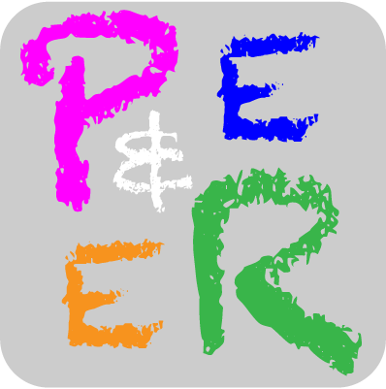
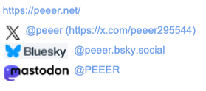

#BetterPublishing

PEEER: Publishing for an Ethical and Equitable Environment in Research

EVENT_TYPE: Event_Name
#:## – #:## am/pm DD Month YEAR Where

Our Mission: To foster a culture in which authors, editors, and reviewers choose publication venues that support affordable and equitable access plus a healthy scientific and research community.

PEEER: Publishing for an Ethical and Equitable Environment in Research

EVENT_TYPE: Event_Name
#:## – #:## am/pm DD Month YEAR Where

